**Chapter 1**

**Introduction**

* 1. **Overview:**

The most crucial energy asset and also essential supportable asset is the solar energy because the vast amount of solar energy is effortlessly accessible for energy generation. Since it is spotless, contamination free and unlimited, the PV systems have been utilized for a long time. The quantity of electric power yield by PV system relies on the climate conditions. Since solar cell VI characteristic is non linear, it is imperative to utilize a MPPT system for extracting maximal energy from the solar panel.

Electric machines are a method for changing over energy. Motors are utilized to change over mechanical energy from electrical energy. In regular daily existence, electrical motors are generally used to power a large number of systems but a developing consideration towards BLDC drive has been examined in this proposed project. Brushless DC (BLDC) motor is a perfect drive for low and medium power applications as a result of its high effectiveness, high torque/inertia ratio, high volume of energy, low maintenance requirement and an extensive variety of speed control. It is otherwise called electronically commutated motor as there are no mechanical brushes and commutator. An electronic commutation with the help of rotor position detected by Hall-Effect position sensor is utilized. Consistently, the dc-dc converters are necessary to have stable output voltage regardless of changes under a variety of conditions. In addition, the closed loop controlled dc-dc converters possess over-current and over-voltage protection when they are regulated through current and voltage mode. The closed loop systems are more delicate to ecological condition than the open-loop system. In this way, it is basic to have a controller with low affectability to clamor and natural conditions. The structural configuration of solar PV array fed BLDC motor having a wide consideration of working agreeably under different environmental conditions.

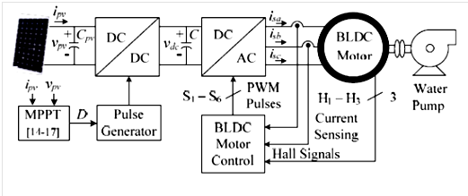

Fig. 1.1 SPV fed BLDC motor driven water pumping system.

The dc-dc converters are predominantly controlled in Voltage Mode Control (VMC) and Current Mode Control (CMC). The VMC has one closed loop where the yield voltage is determined and calibrated with the reference voltage. The Current control mode consists of dual closed loop where the external loop utilizes the yield voltage as feedback signal. The internal closed loop provides feedback signal only by utilizing the inductor current. Additionally current control modes have innate over-current protection and higher transmission than the voltage control mode. The main feature of CMC is the most excellent mode of control for dc-dc converters. In any case, the additional current identifying block, which incorporates the current sensor, the voltage level shifting circuit and the analog to digital converter (ADC) brings lack of quality and additional cost. For these, the sensor less current controlled dc–dc converter/ advanced current control technique, which operates in current control mode with all the previously mentioned points of interest and incredible possibilities however without requiring a current recognizing module. For the PCC, a calculation was explored in to take out the inductor current trouble in current control modes. In any case, all together to keep up the current control loop stability, the particular system of current control mode with pulse width adjustment ought to be done, and it limits the adaptability of framework outline. The viability to take out the unsettling influence in cycle by PCC with leading edge PWM modulation system was checked by hypothetical Derivation.

With the foretasted look into examination, to acknowledge current observer with sensor less current control, an exact framework modeling was executed. But, it is excessively intricate. Subsequently to make the framework straightforward, an input voltage feed forward current observer in terms of computational intricacy was built up. Here, it viably taking out the effect of input voltage fluctuations however current estimation error is generally vast because of overlook of the parasitic parameters. A broadened Kalman filter based current observer was assembled to upgrade the current estimation precision. An overwhelming model to enhance the current control execution was explored. The current estimation blunder happens because of the impact of parasitic parameters. In the previously mentioned research achievements, parameter variation issues and voltage loop steady-state errors are not discussed. To decide parasitic parameters, an extra signal testing module is required, which improves the current estimation all the more precisely. The end goal to get a more exact current estimation error, the grouping of PI controller is presented from the PCC controller. The mix impact of voltage loop PI controller is nullified by zero at origin, to diminishing the output voltage steady state error. The another issue is that the impact of parasitic parameters can bring about the framework shaky. This issue can be tackled by online parameter estimation. In segment III.D PCC, is intended to self correcting the output voltage steady state error can take out the zero at the starting point created by PCC controller to accomplish no output voltage steady state error without considering any parasitic parameters.

Already buck, boost and buck-boost converters have been utilized to improve PV system efficiency by transferring the generated output power from PV array to load. Zeta Converter with the presence of output inductor provides the constant current with ripple free. Even though combination of similar type of components as a Cuk converter, the zeta converter functioning as non-inverting buck-boost converter. This main feature prevent occurrence of additional circuits for negative voltage sensing henceforth minimizing intricacy and restrain the system response. A zeta converter which conveys directed yield voltage with power quality and to enhance proficiency. The advanced framework is controlled in two phases, viz. INC-MPPT and PCC technique.

Different MPPT techniques have been considered in PV power applications. The previous perturb and observe (P&O) and hill climbing strategies, tracks the maximum power point (MPP) by more than once incrementing or decrementing the yield voltage at the MPP of the PV module. The execution of the strategy is generally basic, yet it can't track the MPP when the irradiance differs rapidly with time.

Likewise, it might bring about framework climate over the extreme power points because of impact of estimation commotion. The incremental conductance strategy is too frequently utilized as a part of PV frameworks. This strategy tracks the MPP by looking at the incremental and prompt conductance of the PV array. It requires less conversion time, and the direct control of duty cycle is accommodated with this work.

**Chapter 2**

**Literature Survey**

Rajan Kumar, Bhim Singh in [1] proposes a simple, cost effective and efficient brushless DC (BLDC) motor drive for solar photovoltaic (SPV) array fed water pumping system. A zeta converter is utilized in order to extract the maximum available power from the SPV array. The proposed control algorithm eliminates phase current sensors and adapts a fundamental frequency switching of the voltage source inverter (VSI), thus avoiding the power losses due to high frequency switching. No additional control or circuitry is used for speed control of the BLDC motor. The speed is controlled through a variable DC link voltage of VSI. An appropriate control of zeta converter through the incremental conductance maximum power point tracking (INC-MPPT) algorithm offers soft starting of the BLDC motor.

S. Iyappan, R. Ramaprabha in [2] This technical paper focuses about the design and implementation of brushless dc (BLDC) motor based solar water pumping system for agriculture For extracting the maximum power generated by photovoltaic array (PV) array, Cuk converter is used as maximum power point tracker with basic perturb and observe (P&O) algorithm. The dc link voltage obtained from the Cuk converter is fed to three phase inverter to provide proper supply to BLDC motor. The BLDC motor pumping system is selected among other motor pumping systems, because it has won features like small in size, noiseless operation, long operating life, less maintenance and high output torque. The performance of the system has been validated using Arduino UNO. The given design can be used for any size of land by simply recalculating the parameters.

Ashish Kumar Singhal in [3] The solar vehicle is a step in saving these nonrenewable sources of energy. The basic principle of Solar/Electric Powered Hybrid Vehicle (SEPHV) is to use energy that is stored in a battery during and after charging it from a solar panel. The charged batteries are used to drive the motor which serves here as an engine and moves the vehicle in reverse or forward direction. The electrical tapping rheostat is provided to control the motor speed. This avoids excess flow of current when the vehicle is supposed to be stopped suddenly as in normal cars with regards to fuel. This idea, in future, may help to protect our fuels from getting extinguished. This view ignited us to develop SEPHV. This multicharging vehicle can charge itself from both solar and electric power. The vehicle is altered out of a two-wheeler vehicle by replacing its engine with a 48 V brushless DC (BLDC) motor.

Trishan Esram and Patrick L. Chapman in [4] The many different techniques for maximum power point tracking of photovoltaic (PV) arrays are discussed. The techniques are taken from the literature dating back to the earliest methods. It is shown that at least 19 distinct methods have been introduced in the literature, with many variations on implementation. This paper should serve as a convenient reference for future work in PV power generation.

Arjav Harjai Abhishek, Bhardwaj Mrutyunjaya, Sandhibigraha in [5] explained different techniques for MPPT such as Perturb and Observe (hill climbing method),Incremental conductance, Fractional Short Circuit Current, Fractional Open Circuit Voltage,Fuzzy Control, Neural Network Control etc. Among all the methods Perturb and observe (P&O)and Incremental conductance are most commonly used because of their simple implementation, lesser time to track the MPP and several other economic reasons. Under abruptly changing weather conditions (irradiance level) as MPP changes continuously, P&O takes it as a change in MPP due to perturbation rather than that of irradiance and sometimes ends up in calculating wrong MPP However this problem gets avoided in Incremental Conductance method as the algorithm takes two samples of voltage and current to calculate MPP. However, instead of higher efficiency the complexity of the algorithm is very high compared to the previous one and hence the cost of implementation increases. So we have to mitigate with a trade off between complexity and efficiency.

Dr. R. Anand and M. Chella Deepika in [6] The role of INC is to overcome the inconveniences of Perturb and Observe MPPT algorithm. The INC work towards the unique operating point called MPP and stop the direction of perturbation. The INC- MPPT algorithm employs the slope of the PV characteristics to find the MPP when the system experiences rapidly expanding and diminishing irradiance conditions. The task of MPPT to calculate reference voltage at which PV array compelled to operate. Once the reference voltage equals VMPP is accomplished, the activity of the PV module is kept at this point otherwise a change in current exists as a result of a change in weather conditions directing to a fluctuation in MPP. This technique is based on the slope of curve dI/dV that negative on the right of the MPP and positive on the left of the MPP and zero at MPP.

**Chapter 3**

**Outline of Project**

* 1. **Aim**

To Study and Simulate Solar Powered BLDC Motor in MATLAB

* 1. **Objectives**
* To study the various MPPT Methods for better performance of energy.
* To study the PV module, P-V & I-V curve of solar cell and Zeta Converter for achieving efficiency.
* To perform mathematical analysis and modeling of PV module with
* Zeta Converter in MATLAB/SIMULINK.
* To develop prototype model of VSI and close loop controlled BLDC motor.
* To compare reference and software (MATLAB/SIMULINK) results.
  1. **Methodology**
* Software Based Simulation
* Software Used:- MATLAB R2014a
* MPPT (INC) Is Used To Extract Maximum Power Form solar PV Array

**3.4 Outlines of the Project Work**

* Chapter 1: Introduction
  + - In this chapter the basic information about the propose d system, its advantages over conventional methods are discussed. Objectives of this study, methodology used for project work and the future scope of this project is briefly covered.
* Chapter 2: Literature Survey & Review
  + - It covers the literature studies of PV modules, Zeta Converter, MPPT theories, BLDC motor control techniques and its applications are mentioned which could be used as input for software development. Literature Review has been mentioned for obtaining desired information.
* Chapter 3: System Description
  + - In this chapter different MPPT methods, PV modules, Zeta converter, Voltage source inverter with BLDC motor, close loop control of BLDC motor using hall sensor feedback, Block diagram of overall system are briefly discussed.
* Chapter 4: Performance and comparative study of the system
  + - The simulation models for Solar PV array, Zeta converter, Voltage source inverter with BLDC motor, close loop control of BLDC motor using hall sensor feedback, are simulate in MATLAB software and respective Results are obtained. These results are compared with the standard reference results.
* Chapter 5: Conclusion and Future Scope
  + - The conclusions are made based on the performance of system and the analytical results and the future scope is also presented in this chapter.
* References
* Appendices

**Chapter 4**

**Design Aspects of Project**

**4.1 Block Diagram:**

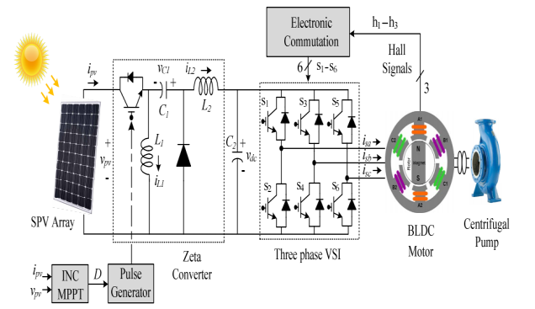

**Figure 4.1: Block diagram of Model**

**4.2 Photovoltaic (PV) Module:**

A solar cell is basically a p-n junction fabricated in a thin wafer of semiconductor. The electromagnetic radiation of solar energy can be directly converted to electricity through photovoltaic effect. Being exposed to the sunlight, photons with energy greater than the band-gap energy of the semiconductor creates some electron-hole pairs proportional to the incident irradiation. The equivalent circuit of a PV cell is as shown in Figure 4.2.

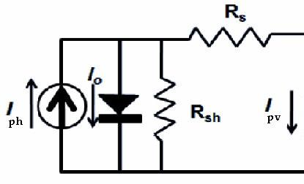

**Figure 4.2: Solar PV cell**

The current source Iph represents the cell photocurrent. Rsh and Rs are the intrinsic shunt and series resistances of the cell, respectively. Usually the value of Rsh is very large and that of Rs is very small, hence they may be neglected to simplify the analysis.

PV cells are grouped in larger units called PV modules which are further interconnected in a parallel-series configuration to form PV arrays. The photovoltaic panel can be modeled mathematically as given in equations

Module photo-current:

Module reverse saturation current

The module saturation current Irs varies with the cell temperature, which is given by

The output current of PV module is

Where

Vpv is output voltage of a PV module (V)

Ipv is output current of a PV module (A)

Tr is the reference temperature = 298 K

T is the module operating temperature in Kelvin

Iph is the light generated current in a PV module (A)

Irs is the cell reverse saturation current (A)

A = B is an ideality factor = 1.6

K is Boltzmann constant = 1.3805 × 10-23 J/K

q is Electron charge = 1.6 × 10-19 C

Rs is the series resistance of a PV module

Iscr is the PV module short-circuit current

Ki is the short-circuit current temperature co-efficient

ʎ is the PV module illumination (W/m2) = 1000W/m2

Ego is the band gap for silicon = 1.1 eV

K0 is constant, Ns is the number of cells connected in series Np is the number of cells connected in parallel.

Power-versus-Voltage and Current-versus-Voltage Curve of solar cell for given temperature and solar irradiation

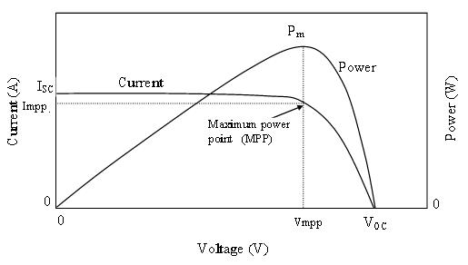

**Figure 4.3 P-V I-V curve of a solar cell at given temperature and solar irradiation**

Figure 4.3 shows the power-versus-voltage curve and current-versus- voltage curve of a PV module. It gives an idea about the significant points on I-V curve: open-circuit voltage, short circuit current, and the operating point where the module performs the maximum power (MPP). This point is related to a voltage and a current that are Vmpp and Impp, respectively, and is highly dependent on solar irradiation and ambient temperature.

**4.3 Zeta Converter:**

It’s a DC-DC Convertor, Made up of 2 capacitors & 2 Inductors; Capable of operating in either Step-up or Step-down Mode Used to draw maximum power from the Solar PV array with minimum power losses. Pulse Generator is used to operate Zeta convertor. Works on the principle of Incremental conductance-Maximum power point tracking Algorithm. (INC-MPPT), due to this soft starting of BLDC Motor is possible. Output current is continuous & ripple free, Output efficiency is high & Economical. The zeta converter is the next stage to the SPV array. Its design consists of the estimation of the various components such as input inductor, L1, output inductor, L2and intermediate capacitor, C1. These components are so designed that the zeta converter always operated in continuous conduction mode resulting in the reduced stress on them.

Duty Cycle:

Average Current Flowing thorough the dc link:

**4.4 Voltage Source Inverter:**

It is used to transfer real power from a DC Power source to AC Load (Motor acts as a AC Load) Avoids power losses due to higher switching frequency. VSI is operated in Fundamental Frequency Switching through an Electronic Commutation of BLDC Motors, which eliminated power losses and improves Efficiency. A new design approach for the estimation of DC link capacitor of the VSI is presented in this sub-section. This approach is based on a fact that 6th harmonic component of the supply (AC) voltage is reflected on the DC side as a dominant harmonic in the three phase supply system. Here, the fundamental frequencies of the output voltage of the VSI are estimated corresponding to the rated speed and the minimum speed of the BLDC motor essentially required to pump the water. These two frequencies are further used to estimate the values of their corresponding capacitors. Out of the two estimated capacitors, larger one is selected to assure the satisfactory operation of the proposed system even under the duration of minimum solar irradiance level.

**4.5 Introduction To Bldc Motor:**

#### 4.5.1 Brushless DC motor history:

Initially, the BLDC motor was found in the year1962, when the scientists T.G. Wilson and his associate P.H. Trickey made a “DC Machine with solid State Commutation”. BLDC motor was consequently known as high torque as well as high response drive for special application. The applications are robotics, tapes for computers. Also it is used in aircrafts where wear of brush was unable to tolerate because of lower humidity. Practically, in later years, the technology for making a motor that can be used for industrial purpose over 5 HP doesn’t exists. The arrival of precise permanent magnet material of high voltage, higher power, transistors of earlier 80s to mid-80s causes it able for making this D.C. motor practical, a reality. Now a day’s, about all chief manufacturers makes brushless DC ranging from ½ HP to around 300 HP. Thus BLDC has a strong effect in industries and market areas.

BLDC motor is moderately new class of motors. The applications of BLDC motors are increasing at a rapid rate every year, due to both the decreasing costs and increasing functionality.

**4.5.2 A Brushless D.C (BLDC) motor:**

A BLDC motor is analogous to Brushed DC motor, differing only in way, that it has a feedback of a shaft position. This feedback decides which windings to get switched ON at what particular moment exactly. Internal shaft position feedback offers both motors their distinctive characteristics. Speed-torque curves are linear and are suitable for position and speed control requirements. In brushed DC motor, this internal shaft position feedback is done with mechanical commutator. Current in the commutator bars is fed through mechanical brushes and are sequentially switched into proper armature winding. Whereas, in a BLDC motor, internal position feedback is done by using a feedback sensor that gives the necessary information of position of the shaft. In turn, drive switches ON the proper winding at the exact moment. The power that is used to drive a BLDC motor can be AC and DC both. If it is AC, in case, the drive has the required circuitry for converting AC power into DC.

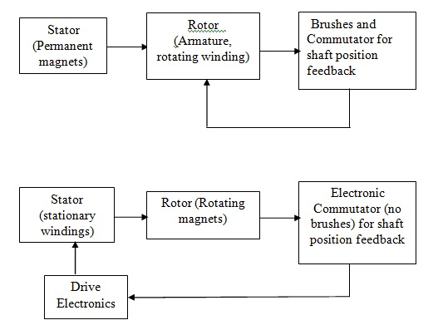

**Figure 4.4: Layout of brush type and brushless DC motor**

In both, brushed DC and Brushless DC motors, the position feedback gives the motor a linear speed-torque characteristics and high starting torque. These are very essential for clear-cut position and speed control. In the brush type DC motor, the internal feedback is with brushes and a mechanical commutator whereas in the case of brushless DC motors, internal feedback is by means of some electronic feedback sensors such as, encoders, magnetic hall sensors or resolvers. The important point is that the windings should be sequentially switched with the drive electronics in case of BLDC motors. The motor even cannot run without the electronic. Conversely, it may be said that BLDC have electronics, these may be used to accomplish adjustable speed control functions and other useful functions.

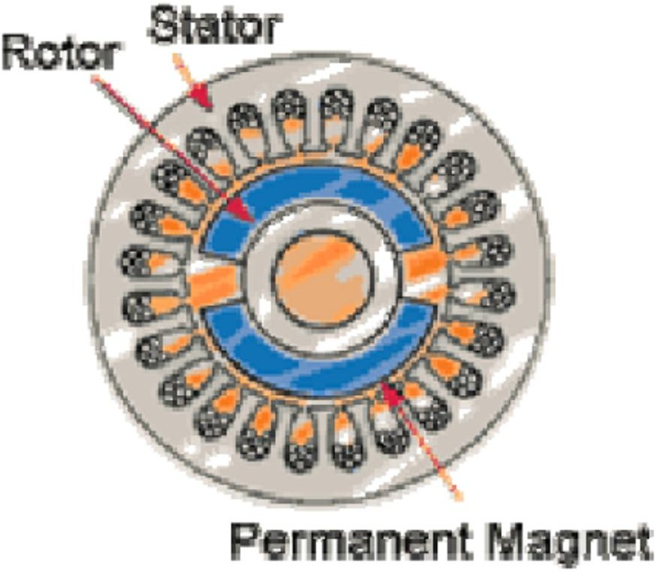

**Figure 4.5: Cross section of typical BLDC motor**

Fig. 4.5 shows a cross section of a typical brushless DC motor. From figure 3.2 the permanent magnets are inside the rotor. The stator is outside and has the windings. BLDC motor is capable of very high positioning system having start and stop function. Brushless Direct Current motors (BLDC) are getting popular today. BLDC motor has lot of advantages over induction motors and induction motors.

Moreover, the ratio of torque to size of the BLDC motor is high which is required in the applications in where weight and space are significant factors .

**Construction:**

Two stator winding constructions are there: trapezoidal motors as well as sinusoidal motors. The discrimination is done on the base of interlinking of coils in stator winding that gives different types of back EMF.

As the name indicates, the sinusoidal motor has back electromotive force in sinusoidal manner and trapezoidal motor has a back electromotive force in trapezoidal shape, as shown in fig. 4.6 and fig. 4.7

BLDC motor has trapezoidal back EMF. The stator winding is fed with rectangular current to give a constant torque [14]. Along with back EMF, the phase current also has trapezoidal as well as sinusoidal variants in the BLDC and brushed motors. Hence the sinusoidal output is smoother than trapezoidal output. As it takes more costing, the copper intake of windings increase.

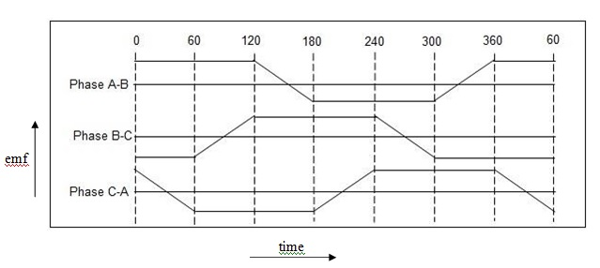

**Figure 4.6: Trapezoidal back EMF**

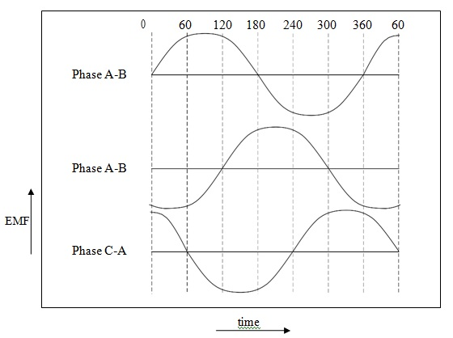

**Figure 4.7: Sinusoidal back EMF**

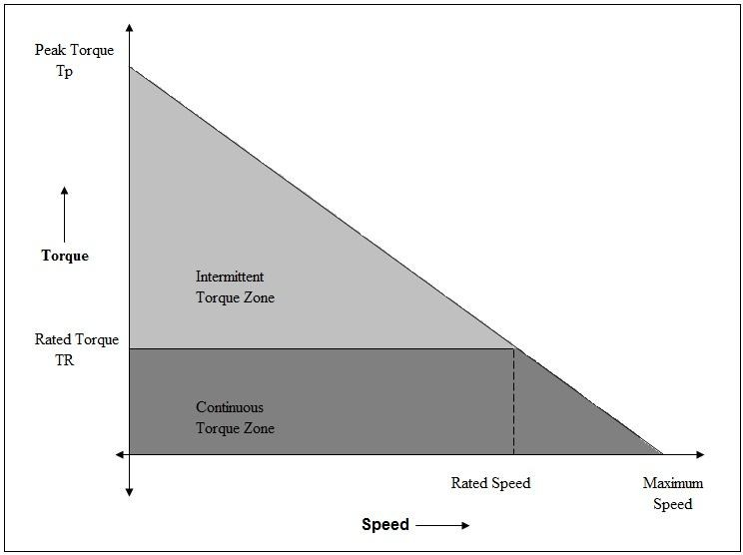Fig. 4.8 shows the BLDC motor torque verses speed characteristics. Two torque parameters are used for defining the torque/speed characteristics of a BLDC motor. These are the rated torque (TR) and peak torque (TP). This speed can be extended up to 150% of rated speed, then the dropping of torque starts. BLDC motor can run to its maximum limit of speed. This motor is able to deliver up to peak torque (TP), if the speed verses torque characteristics are followed.

**Figure 4.8: Torque verses speed characteristics**

**BLDC motor comparison with other types of motor:**

As compared to induction motors as well as brushed DC motors, brushless DC motors have several advantages and disadvantages. These produce more power output than that of an induction motor and brushed DC motors. Inertia of rotor is lesser, as the rotor is made up of permanent magnet material. It improves the deceleration and acceleration characteristics, thus the operating cycle s are shortened. BLDC motors need lesser maintenance. Thus, these have a long life. Linear speed verses torque characteristics produces better regulation of speed as predictable.

In case of brushless motors, inspection for brushes is eliminated this makes them perfect for limited access area applications. In these applications, servicing is tedious. Operation of BLDC motor is quiet than brushed DC motors, thus Electromagnetic Interference (EMI) reduces.

**Controller Implementations:**

Controller requires some sort of means for deciding the orientation of rotor or rotor position in reference to the stator coils, as it must direct the rotor rotation. Certain design uses rotary encoders or Hall effect sensors for measured position of the rotor directly while some others only measure the back EMF. Back EMF is measured in not driven coils to deduce the position of the rotor. Thereby the Hall effect sensors are eliminated. Hence, these are called as sensor less controllers. The voltage on the not driven coils is sinusoidal as in AC motor, but over the throughout commutation period the output appears to be trapezoidal due to the DC output of the controller. As being a part of the controller, 3 bi-directional drives, drives a very high-current DC power, it can be controlled by using logic circuit.

Controller that senses the position of rotor depending on back-EMF has more obstacles in initiating the motion. This is because back EMF is not developed when rotor position is standby. It is generally done by starting the rotation from any arbitrary phase, and later on skipping to the correct one. If in case, it can be wrong, then it will cause motor to run in a backward direction, by adding more complication to the start-up sequence. Senseless controllers are able to measure windings saturation. The crucial points regarding BLDC controller are;

* The basic cost of controllers is in power transistors and these are coming down. Larger motors use IGBT as main switching element while smaller motors (3 HP or less) use MOSFET.
* Companies that are more expert in both i.e. power electronics technology as well as in motor technology have a higher chance of giving solutions successfully.

**Typical BLDC motor applications:**

Brushless DC motors have its applications in almost every sector. BLDC motors have applications in, appliance, automotive, industrial controls, aviation etc. This can be classified as per types of loads;

* Constant load applications
* Varying load applications
* Positioning applications

**Constant load applications:**

In this type of application, speed variable is more crucial than a precision of the set speed. Also, the deceleration and acceleration rates are not changing dynamically. In this type, the shaft of the motor is directly coupled to load. Pumps, fans and blowers are good examples of this type. This application demands low-cost controllers when operating in an open-loop.

**Varying load applications:**

In this type of application, the motor load varies over a certain speed range. Application under varying loads demand accuracy, control of high speed response. . Examples are washers, compressors and many home appliances. Other examples are automotive, control of electronic steering, electric vehicle control and engine control. There are a numerous applications in automation, like robotic arm controls, centrifuge, pumps etc. This category can be a closed loop or semi closed loop. It complicates the controller by involving advanced algorithms. So cost of the system increases [2].

**Positioning applications:**

This application involves most of the industrial and automation types. This category involves the applications of power transmission. This type of application has importance of

dynamic response of torque and speed. These can have repeated rotations reversals. Motor load varies during all phases which cause it as more complicated. This category mostly operates in close loop. This category has three control loops. The performance of loops is simultaneous. Speed, torque and position control are the three loops [2]. Example is a Computer numeric controlled (CNC) machine [8].

**Other applications:**

* Home Application: milk tea and coffee machine
* Medical Apparatus: surgery tools, medical pump, centrifugal machine
* Industry Equipment: actuator, electric valve, micro pump
* Business Equipment: copier, projector, ATM, vending machine, printer
* Personal Care: electric shaver, massager, hair dryer

**Concluding remark:**

In conclusion, we may say that the BLDC motors are advantageous over brush motors, DC motors and AC induction motors. They have better speed versus torque characteristics, noiseless operation, rugged construction high speed ranges etc. Motor torque is also high. This makes it important where weight as well as space is vital constituents.

Hence, brushless DC motors are used extensively in many industries.

**Chapter 5**

**Testing Performance Characteristics**

The Modeling of overall System in MATLAB/SIMULINK includes the PV module electrical circuit, the Zeta converter, and the MPPT algorithm, VSI, BLDC motor, hall sensor feedback etc...

The Modeling of overall System has been done in stages as:

* Modeling of PV Panel
* Modeling of MPPT
* Modeling of PV Panel, Zeta Converter with the MPPT
* Modelling of BLDC motor with VSI

**5.1 Modeling of Photovoltaic (PV) Panel:**

The PV module is modeled using electrical characteristics to provide the output current and voltage of the PV module. The provided current and voltage are fed to the converter and the MPPT controller simultaneously.

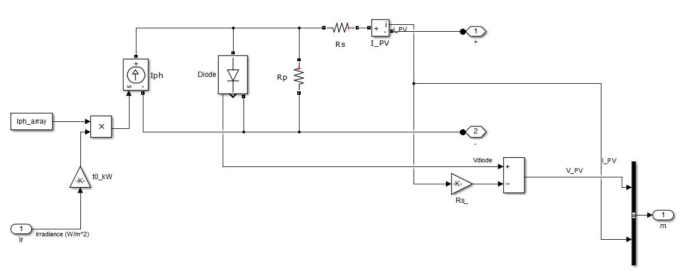

**Figure 5.1: Solar PV model in MATLAB**

Diode characteristic

Id=Isat*[exp(Vd/VT) -1]

where:

Id = diode cuurent (A)

Vd = diode voltage (V)

Isat = diode saturation current (A)

VT = temperature voltage = k*T/q*Qd*Ncell*Nser

T = cell temperature (K),

k = Boltzman constant = 1.3806e-23 J.K^-1

q = electron charge = 1.6022e-19 C

Qd = diode quality factor

Ncell= number of series-connected cells per module

Nser = number of series-connected modules per string

**5.2 Analysis of Photovoltaic Panel:**

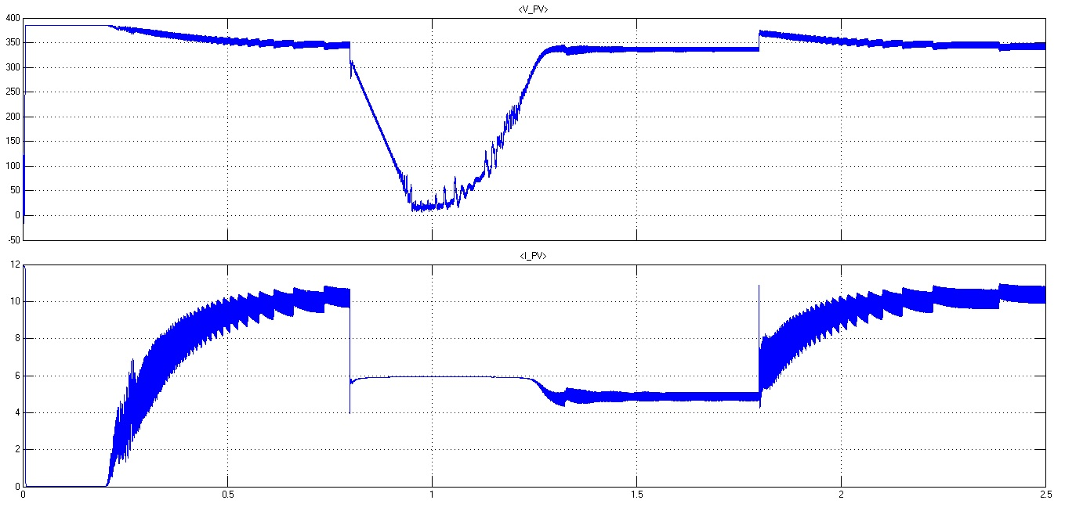

**Figure 5.2: Solar PV array output Vpv and Ipv**

**5.3 Modeling of MPPT System**

Assumptions in Modeling of MPPT System:

1. The environmental conditions are assumed as irradiation 1000W/m2 and temperature as 400C
2. The PV panel of MATLAB/SIMULINK is almost modeled to the hardware PV panel
3. The load impedance of motor have been assumed to the scale of 1 =50K .

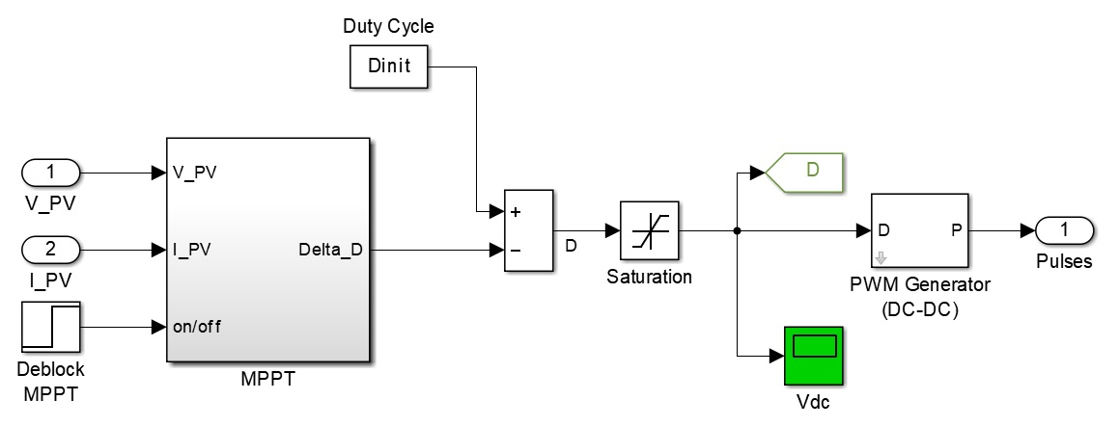

**Figure 4.21 Modelling of MPPT System**

**5.4 Modeling of Zeta Converter:**

The main concern is to design and construct a DC to DC converter which is one of the main modules in the solar PV system. The purpose of the project is to develop DC to DC converter that converts the unregulated DC input to a controlled DC output with desired voltage level. The MATLAB/SIMULINK diagram of Zeta converter is shown in figure 5.4. Output voltage magnitude can be either larger or smaller than that of the input, and there is a polarity reversal on the output. The changes in the duty cycle enables them to operate through short-circuit current to open-circuit voltage. The components for the Zeta converter used in MATLAB/SIMULINK were selected as Inductor (L1): 5mH; Capacitor (C1): 47µF; Inductor (L2): 5mH; Capacitor (C2):1µF and Battery Impedance: 500K .These components were dragged from simulink library browser of MATLAB/SIMULINK.

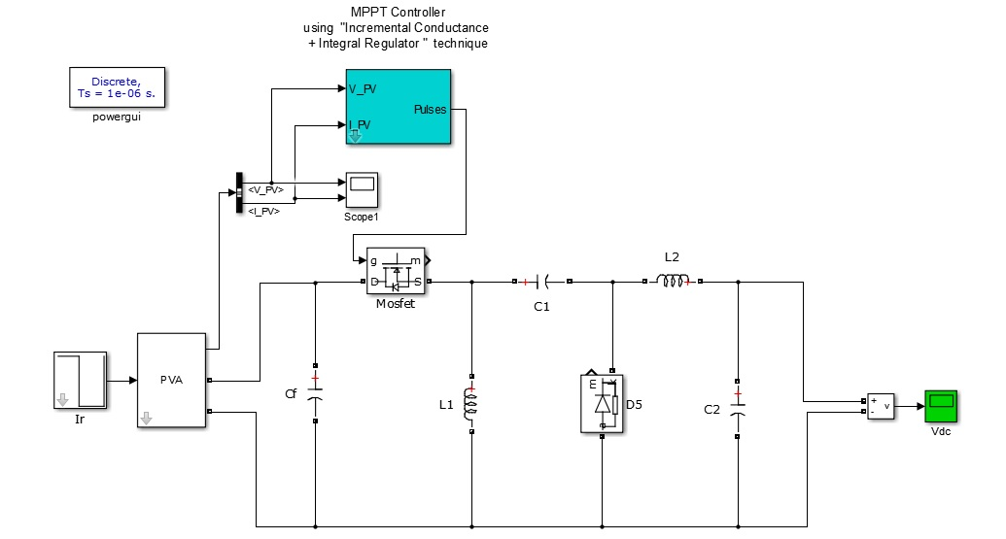

**Figure 5.4: MATLAB model of Zeta converter with solar PV array and MPPT**

**5.5 Analysis of Zeta Converter:**

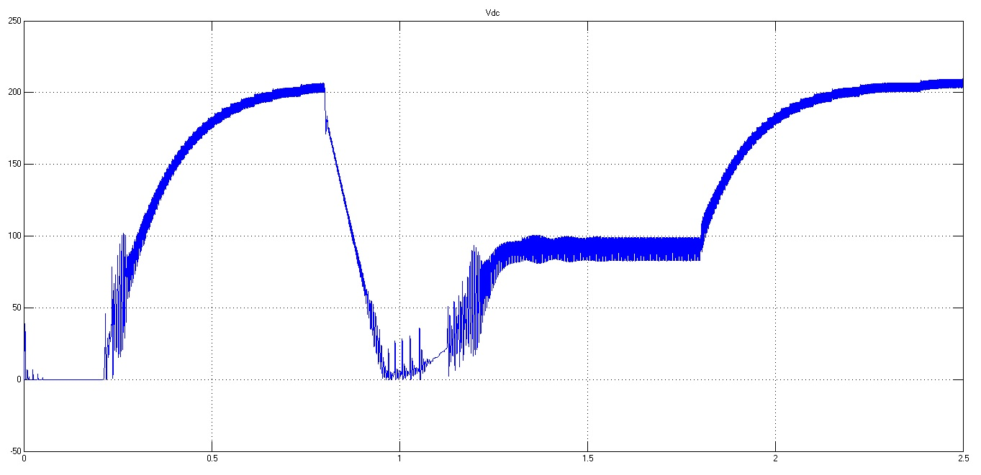

**Figure 5.5: Zeta converter output Vdc**

**5.6 Modeling of BLDC MOTOR WITH VSI:**

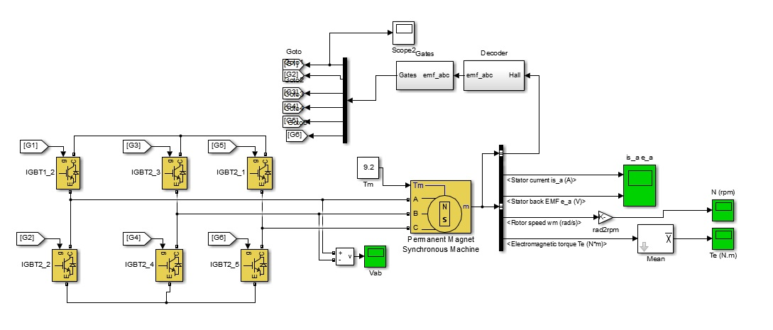

**Figure 5.6: MATLAB model of BLDC motor with VSI and Feedback loop**

**5.7 Modeling Of Overall System:**

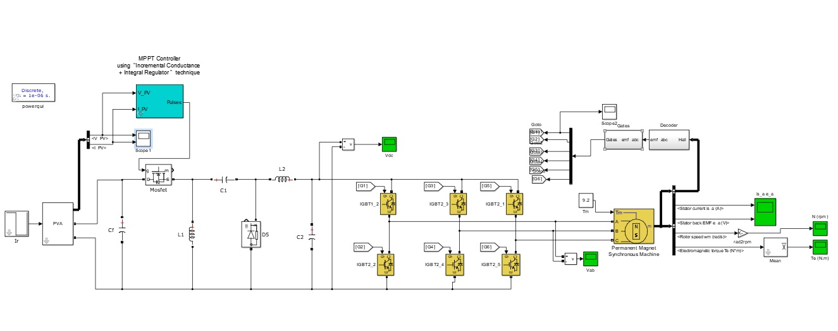

**Figure 5.7: MATLAB model of Proposed system**

**5.8 Analysis of Overall System:**

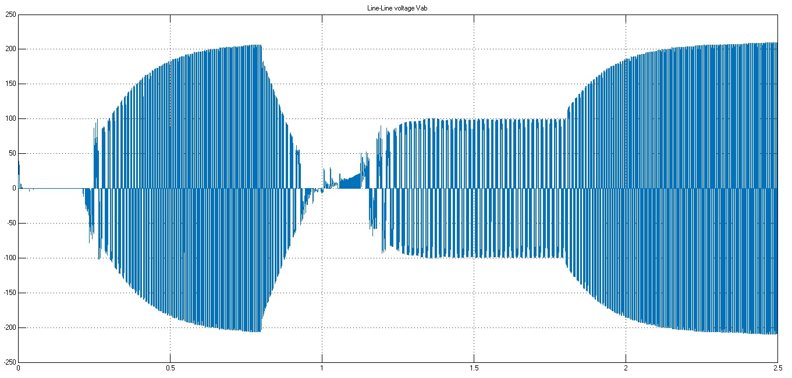

**Figure 5.8: Voltage Source Inverter Output Line To Line Voltage**

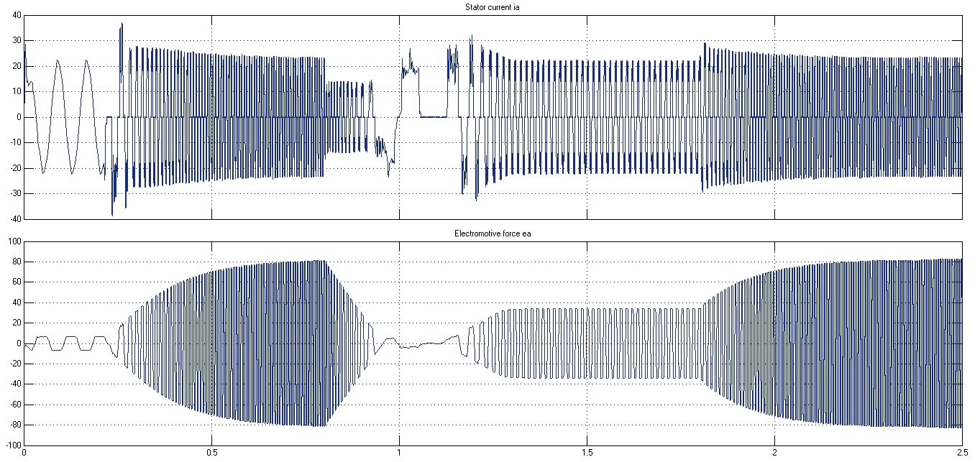

**Figure 5.9: Stator Current and Electromotive Force Developed in BLDC Motor**

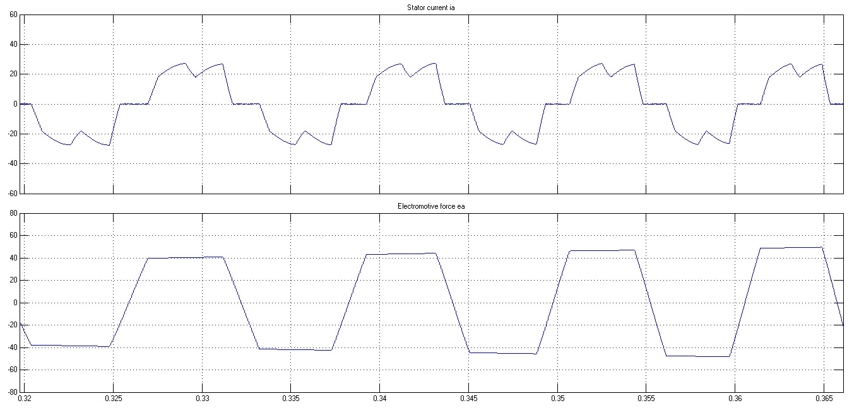

**Figure 5.10: Stator Current and Electromotive Force Developed in BLDC Motor**

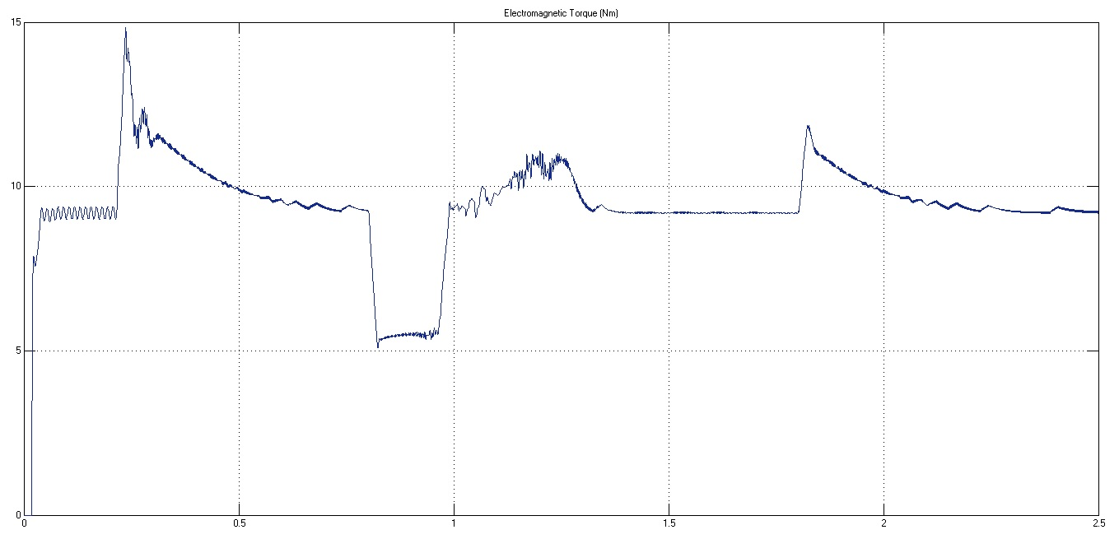

**Figure 5.11: Electromagnetic Torque of BLDC Motor**

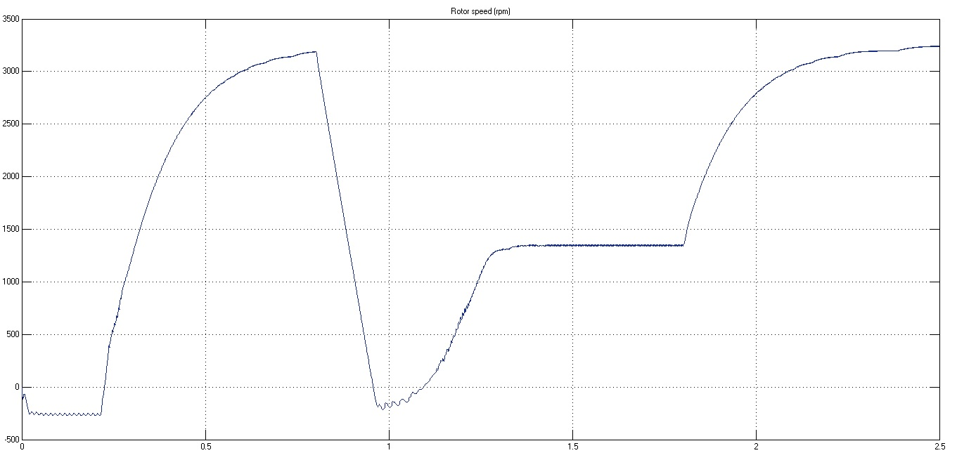

**Figure 5.12: Rotor Speed Of BLDC Motor**

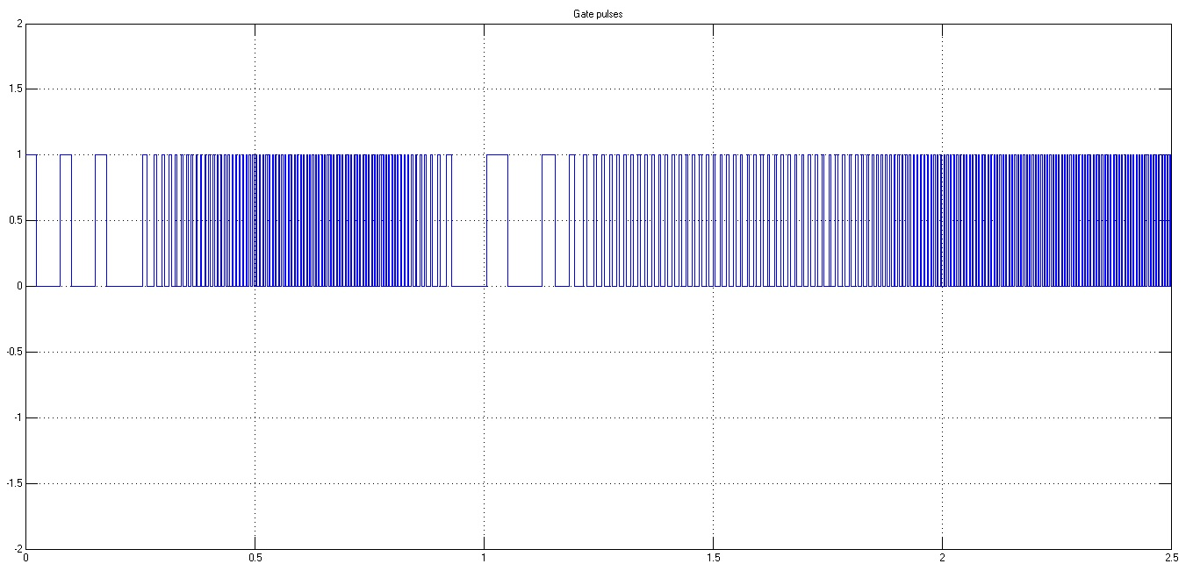

**Figure 5.13: Gate Pulses to VSI**

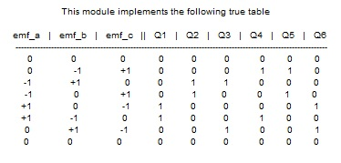

**Figure 5.14: Gate Pulses Sequence Table**

**5.8 Merits and Demerits:**

**Merits:-**

* The MPPT system allows the solar panel to operate at its MPP but uses Zeta Converter to compensate for difference in voltage needed.
* This prevents significant losses as solar panel operates at its voltage even though the voltage required for battery is low. The Zeta converter compensates for this difference.
* The proposed Incremental Conductance method offers different advantages which are: good tracking efficiency, response is high and well control for the extracted power.
* The advantage of MPPT controller is it provides overcharge protection so no need for overvoltage protection of battery.
* The circuitry implemented for Incremental Conductance method is not highly complicated.
* The periodic tuning for the controller is not required.
* This system can employed at remote locations where grid electricity is not available such as Water pumping application in Farm, Hilly areas etc…

**Demerits:-**

* MPPT gets affected in extremely bad weather conditions.
* MPPT systems can be applied to PV panels only.
* Installation cost is very high.
* Proper maintenance is required in case of battery stored applications.
* Not much reliable as system completely depends on Natural conditions

**5.9 Applications**

* + Rural areas
  + Transport sector
  + Agriculture sector
  + Domestic sector
  + Industrial Sector
  + Energy sector

**Chapter 6**

**6.1 Future Scope**

* Availability solar energy is complementary. The combination with wind energy system will further enhance system reliability and efficiency
* Maximum power point tracking can be employed to extract maximum power from solar PV array.
* Speed control of BLDC motor and hence pump can be achieved by hall sensing and VSI control.
* The employment of an inverter in the system will be able to supply grid if it is implemented for large scale
  1. **Conclusion**

The proposed system has been designed and modelled appropriately to accomplish the desired objectives and validated to examine various performances.The performance evaluation has justified the combination of zeta converter and BLDC motor for SPV array based water pumping. The system under study has shown various desired functions such as MPP extraction of the SPV array, soft starting of BLDC motor, fundamental frequency switching of VSI resulting in a reduced switching losses, speed control of BLDC motor without any additional control and an elimination of phase current and DC link voltage sensing, resulting in the reduced cost and complexity. The proposed system has operated successfully even under minimum solar irradiance.

**References**

1. Rajan Kumar, Bhim Singh “BLDC Motor Driven Solar PV Array Fed Water Pumping System Employing Zeta Converter” IEEE Transactions on Industry Applications 0093-9994 (c) 2015 IEEE DOI 10.1109/TIA.2016.2522943
2. S. Iyappan, R. Ramaprabha “Design and Implementation of Brushless DC Motor based Solar Water Pumping System for Agriculture using Arduino UNO” Article in International Journal of Engineering and Technology · February 2017
3. Ashish Kumar Singhal “Journal of Electronic Design Technology Solar Electric Powered Hybrid Vehicle” https://www.researchgate.net/publication/282356190 Article · September 2015
4. Trishan Esram and Patrick L. Chapman “Comparison of Photovoltaic Array Maximum Power Point Tracking Techniques” IEEE Transactions On Energy Conversion, Vol. 22, No. 2, June 2007 439
5. Arjav Harjai Abhishek, Bhardwaj Mrutyunjaya, Sandhibigraha “Study Of Maximum Power Point

Tracking (Mppt) Techniques In A Solar Photovoltaic Array” B-Tech Project NIT Rourkela-2014

1. Dr. R. Anand and M. Chella Deepika “Solar PV Array Employing Zeta Converter Based MPPT Controller Supplying BLDC Motor Drive” Published BYAENSI Publication EISSN: 1998-1090 http://www.aensiweb.com/ANAS 2017 May 11(7): pages 15-25 Open Access Journal